

**The ultimate omnichannel approach to sales and customer management.**

Align work with company objectives.

* Provide a centralized solution for maintaining sales data and customer information.
* Facilitate efficient and accurate transaction management.
* Enable effective tracking of customer details and purchase history.
* Ensure robust security measures to protect sensitive data.
* Monitor inventory levels and alert for low stock to prevent shortages.
* Design an intuitive user interface for ease of use by all staff.
* Generate insightful reports on sales performance and customer activity.



<https://templates.hibootstrap.com/vconn/default/index-2.html>

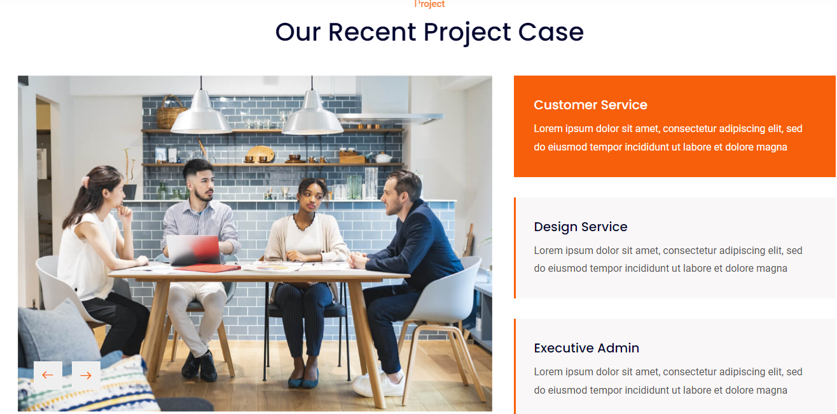

**Why Choose the I Help Omni Pos System?**

1. **Comprehensive Functionality**: This POS system integrates essential features such as sales processing, customer management, and inventory tracking into a single platform, streamlining operations and reducing the need for multiple systems.
2. **Enhanced Data Security**: With robust security protocols in place, this solution ensures that sensitive customer and transaction data is protected, fostering trust and compliance with data protection regulations.
3. **Actionable Insights**: The system's reporting and analytics capabilities provide valuable insights into sales trends and customer behavior, enabling data-driven decision-making that can enhance business performance and drive growth.

**Key Features of the I Help OMNI Pos System**

**Free Core Features**

**Sales Processing:** Supports transactions for product sales with capabilities for applying discounts, tax calculations, and generating digital receipts**.**

**Customer Management:** Stores customer information, such as contact details, purchase history, and preferences, to personalize future engagements and enhance customer experience.

**Inventory Management:** Monitors product stock levels, alerts for low inventory, and allows for adjustments in real-time.

**User Authentication and Security:** Ensures only authorized personnel access the system, with security protocols in place for data protection.

**User Interface (UI) Design:** A user-friendly and intuitive design that enables ease of use for staff at all experience levels**.**

**Paid Core Features**

1. **Payment Integration:**
   * Supports multiple payment options, including credit/debit cards, mobile payments, and cash.
2. **Reporting and Analytics:**
   * Offers detailed reports on sales, revenue, and customer behavior for informed decisions.
3. **Data Segmentation and Marketing:**
   * Enables customer/product segmentation for targeted marketing campaigns.
4. **Complaint Management:**
   * Streamlines the handling of customer complaints to enhance service quality.
5. **Staff Activity Log:**
   * Tracks user activity within the system for accountability and performance evaluation.
6. **Exportable Reports:**
   * Allows reports to be exported in multiple formats (e.g., PDF, Excel).
7. **Data Backup and Recovery:**
   * Automates backups and ensures quick recovery from potential data loss.
8. **Mobile Apps:**
   * Provides mobile versions of the POS system for on-the-go access and usability.

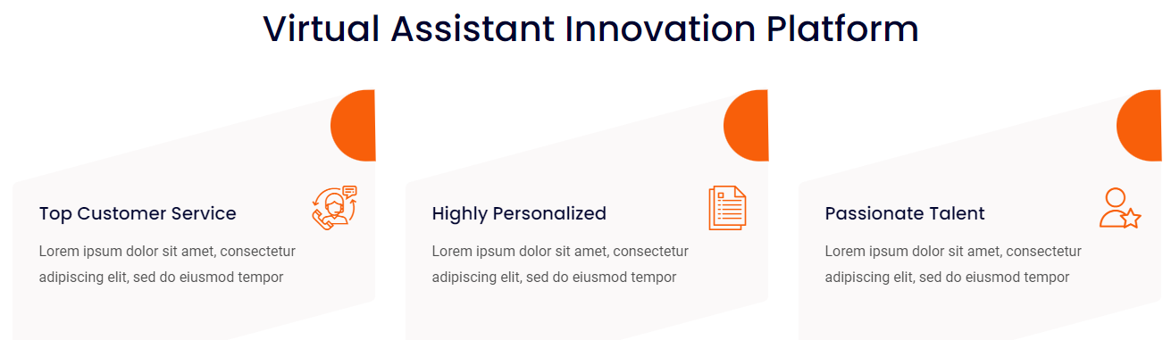

**An Overview of WHY WE NEED Omni Pos System**

**CRM Benefits:**

* **Efficiency**
* **Integration**
* **Usability**
* **Security**
* **Tracking**
* **Flexibility**
* **Insights**
* **Scalability**
* **Automation**
* **Accessibility**
* **Reliability**
* **Customization**
* **Support**
* **Analytics**
* **Performance**



